Wow moments from Autumn Term 1!
We were so impressed with how quickly our new, and returning, nursery children settled in as a class. It has been lovely to see strong friendships being formed, class routines established and lots of engagement and enthusiasm when exploring the indoor and outdoor provision.
Resilience
*Not giving up
*Achieving their goals
*Working together
Relationships
*Supporting each other
*Having fun together
*Sharing ideas
‘Let’s make a bus!’
The girls worked together to construct a bus. It was very tricky trying to hold the pieces and connect the poles, but look what they managed to achieve together! They used their imagination to tell stories about their adventures and sang songs on their bus.

In nursery, children develop their independence by taking on responsibilities and practising the skills needed to achieve a specific outcome. We explored tools and techniques needed to prepare, cook and eat our snack. The children came up with their own shopping list; jelly, cornflakes, chocolate, cake cases & milk. They took on responsibilities for measuring, pouring, timing, checking and sharing the food they made. Great attitude to becoming independent and responsible for your actions and ideas.
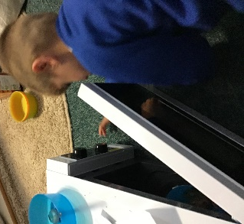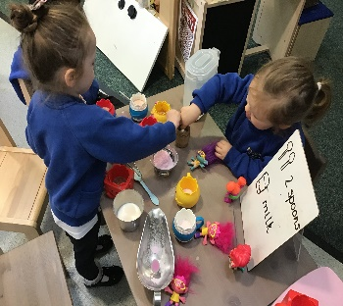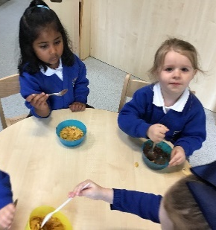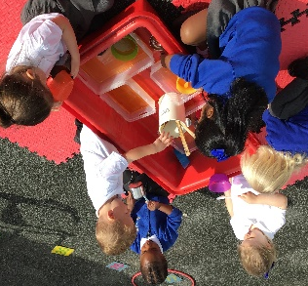
To make our classroom a happy, safe and welcoming environment, we talked about respect. The children understand that listening to each other, taking turns and being kind and caring are very important skills. They said it makes them ‘feel happy to make each other feel happy’ They enjoy caring for their environment and are always willing to help keep it clean and tidy.

Mental Health Awareness.
We made crowns to help talk about thoughts and feelings.

