Reception highlights – Autumn 1
The children made a very positive start to their school life. We have had so much fun in our first half-term and formed a lot of lovely new friendships. This half-term the children learnt all about themselves. We created our own self-portraits for our class Art gallery.
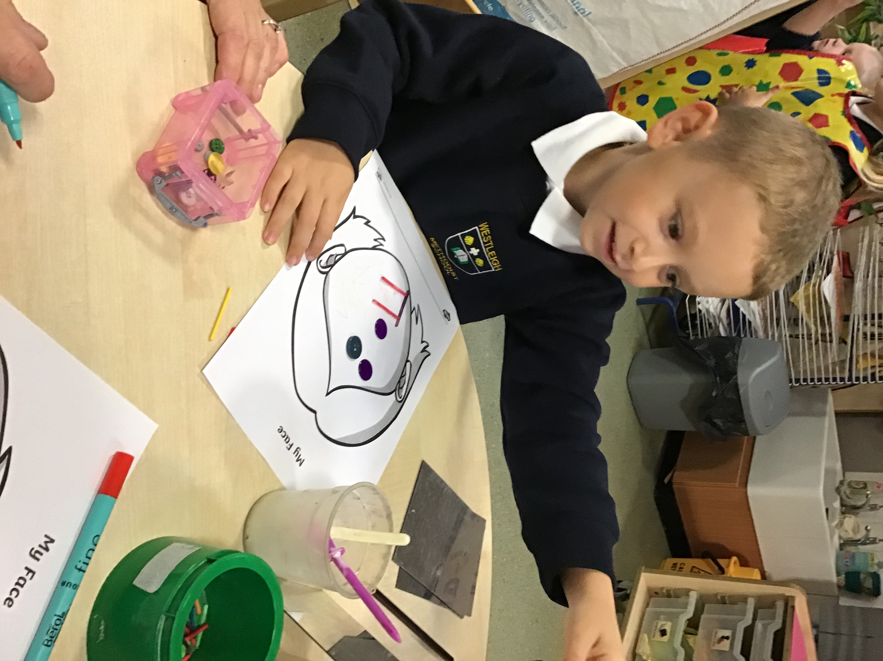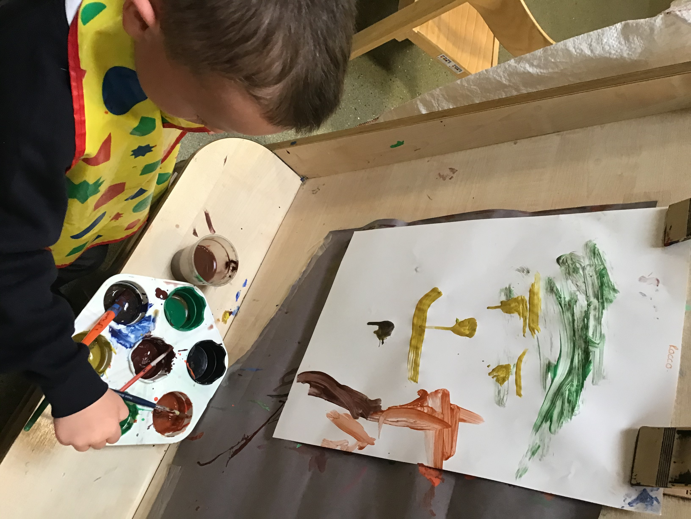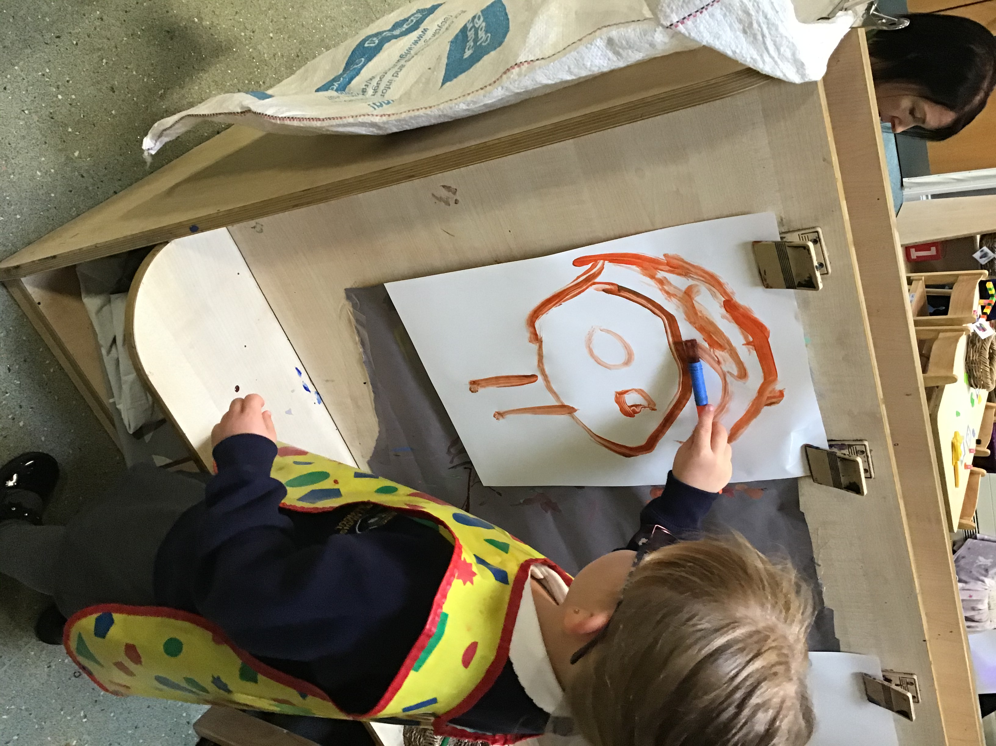

We wrapped a lot of presents up for our class dog, Sausage. This helped to improve our find motor skills as we used our scissors carefully to cut the cello tape. He loved all of his birthday presents!
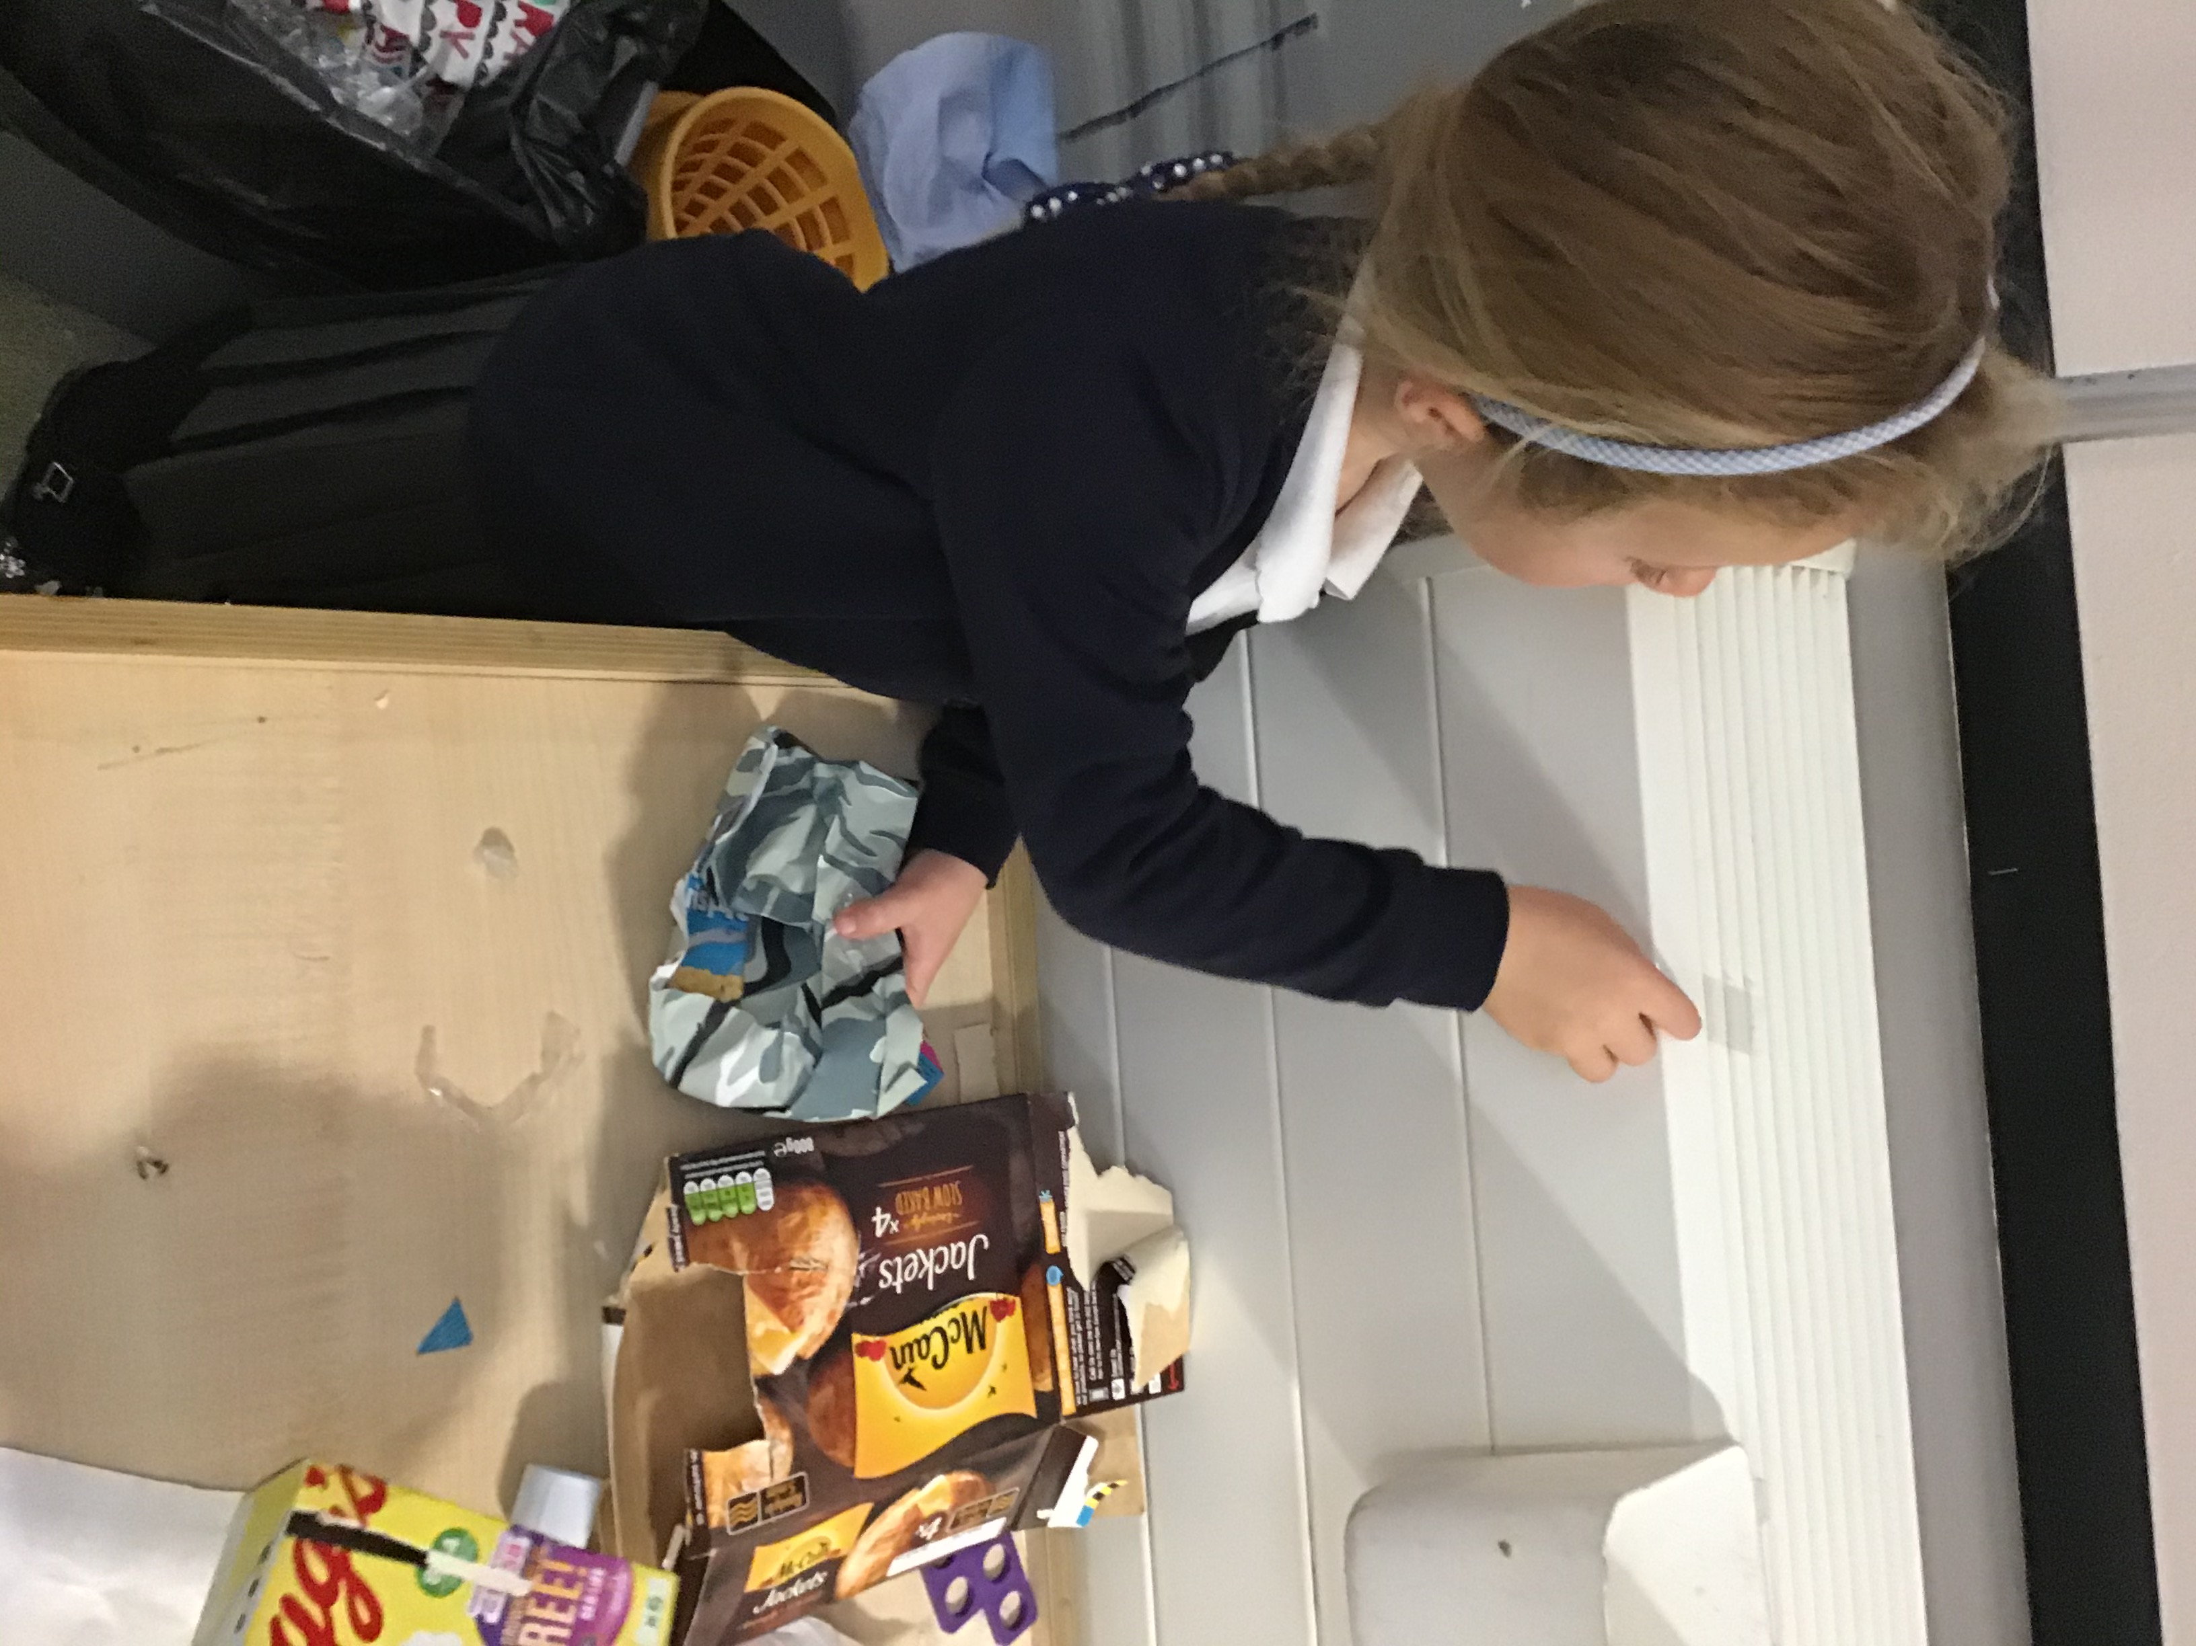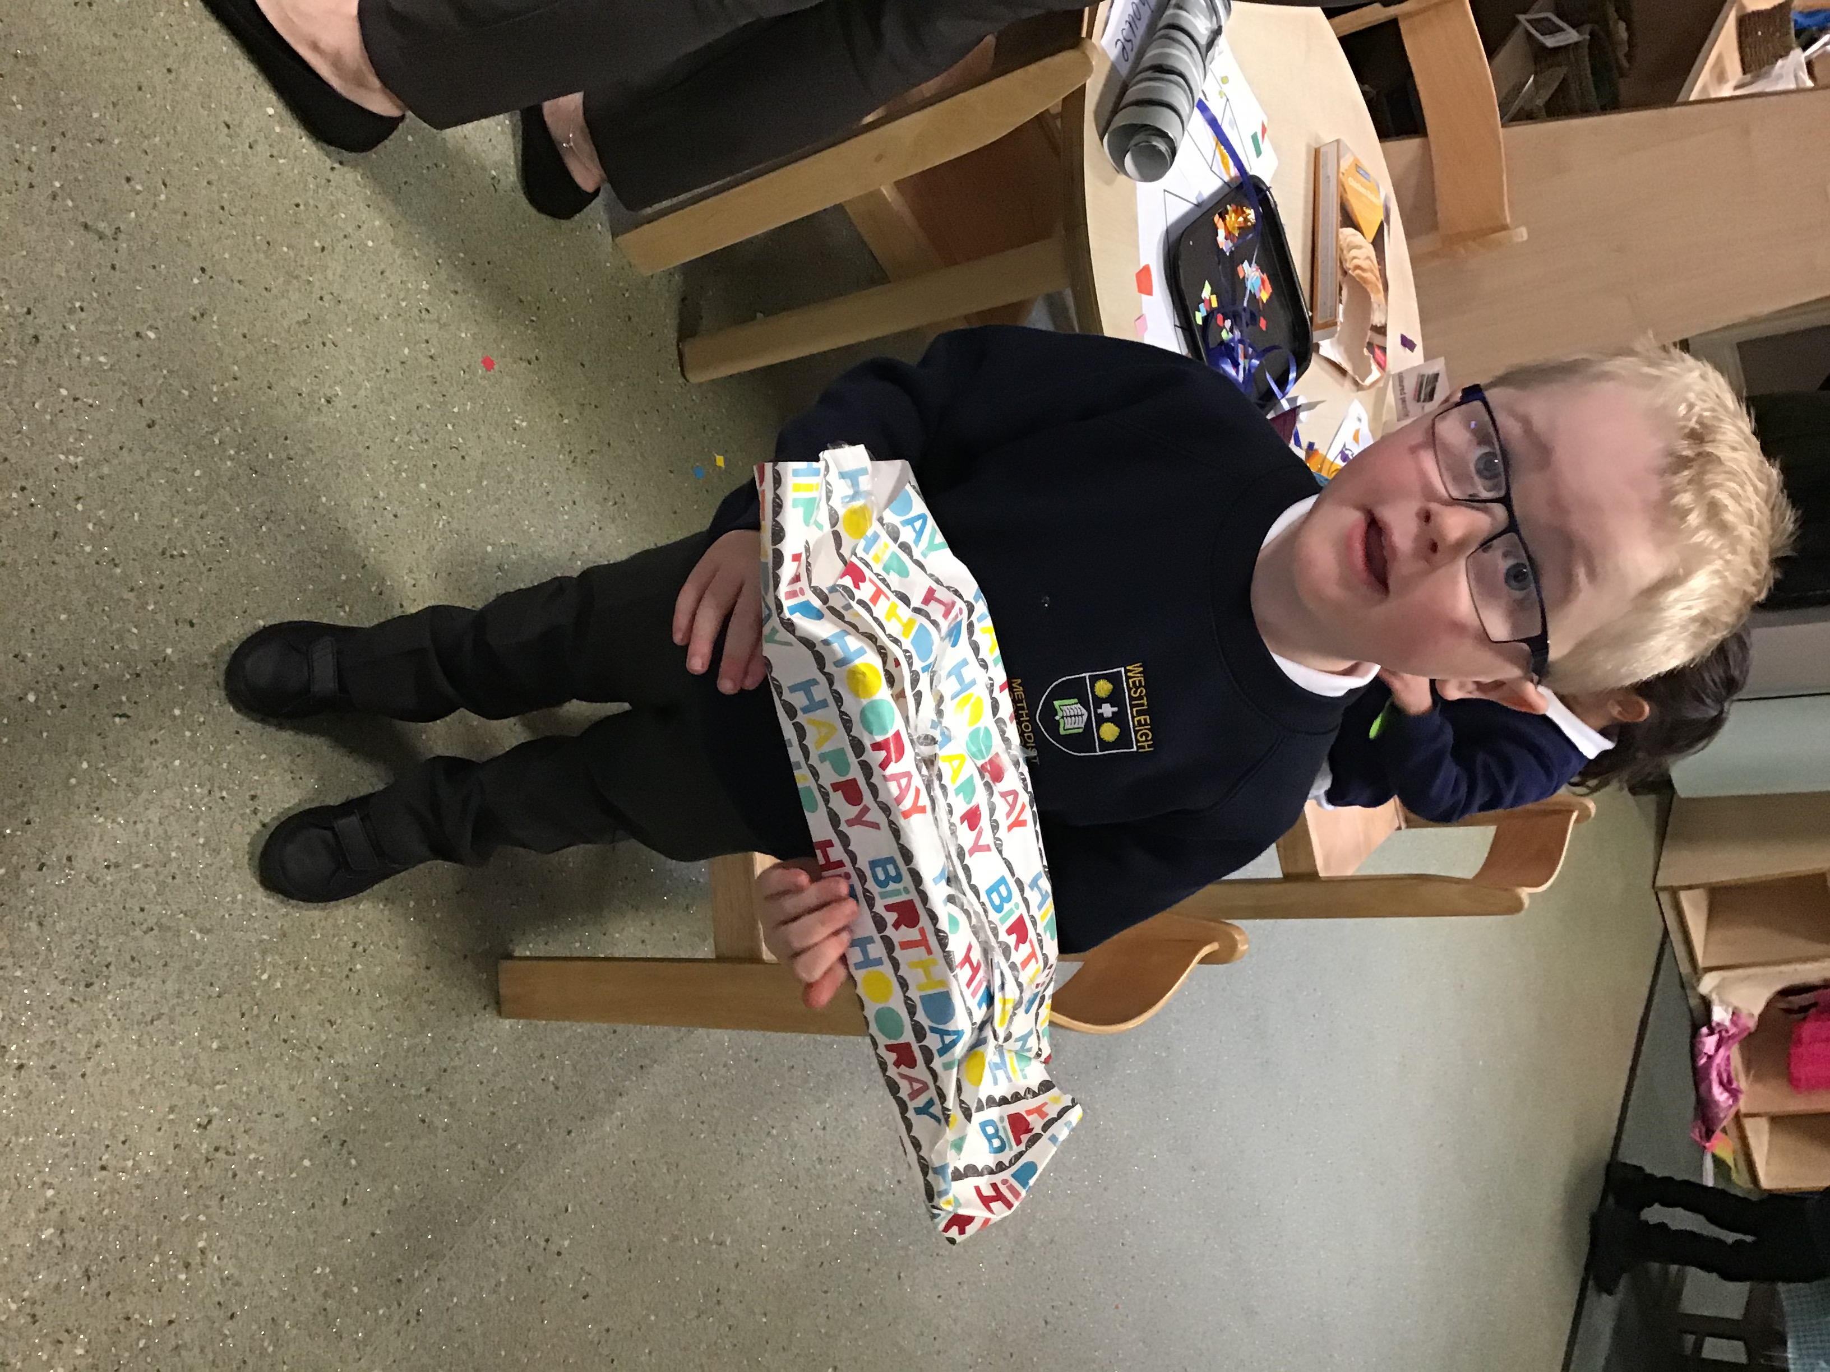

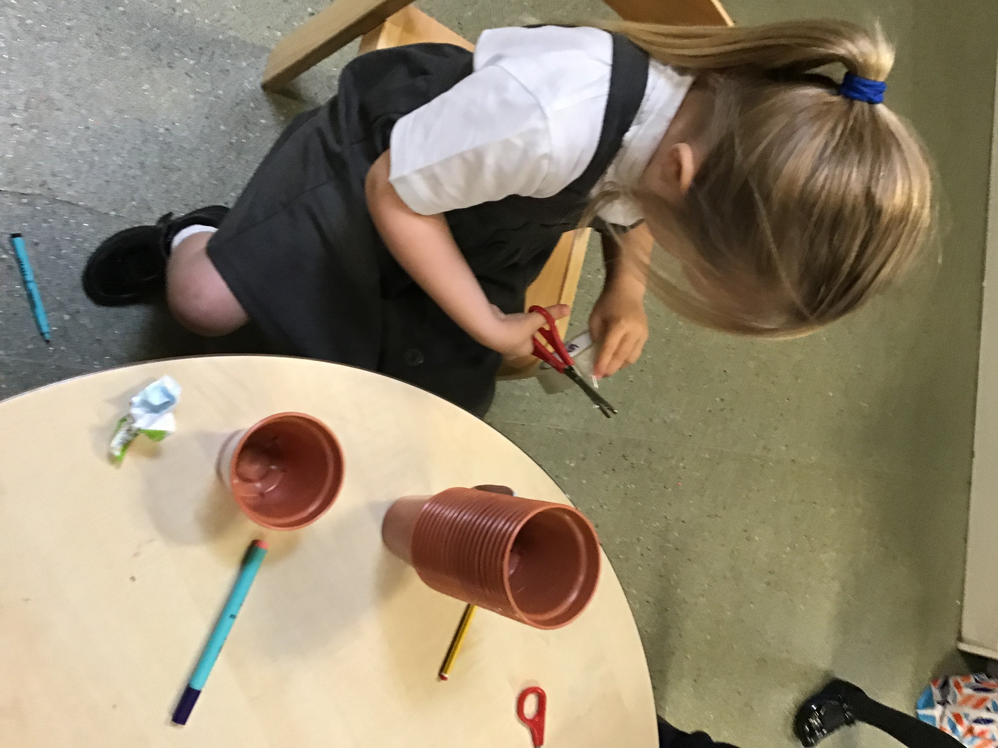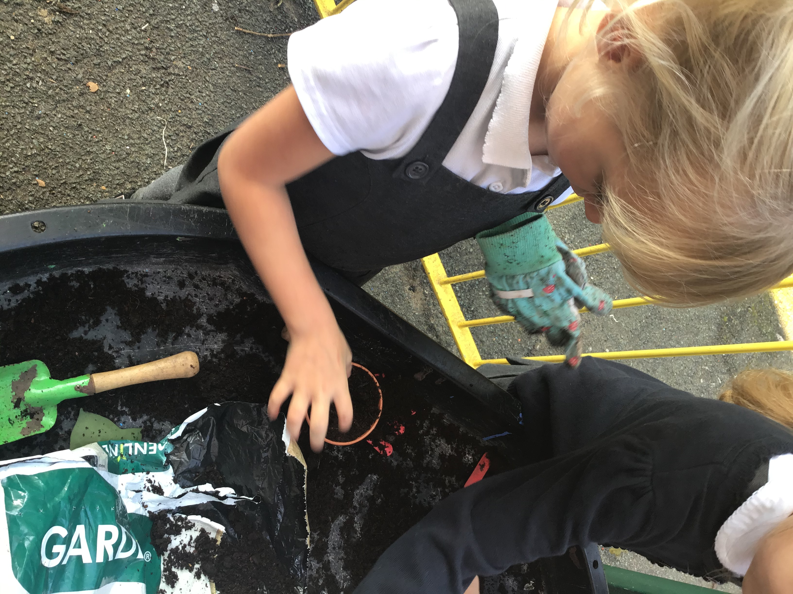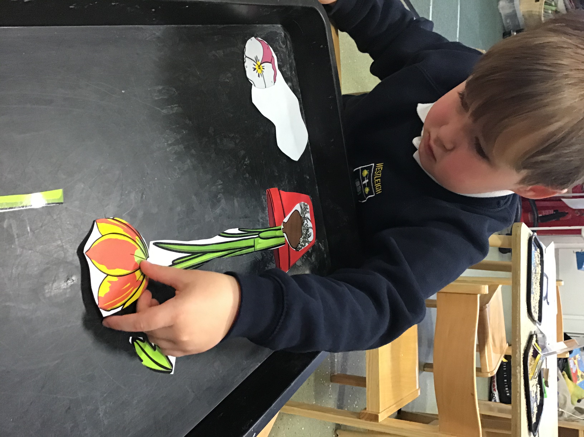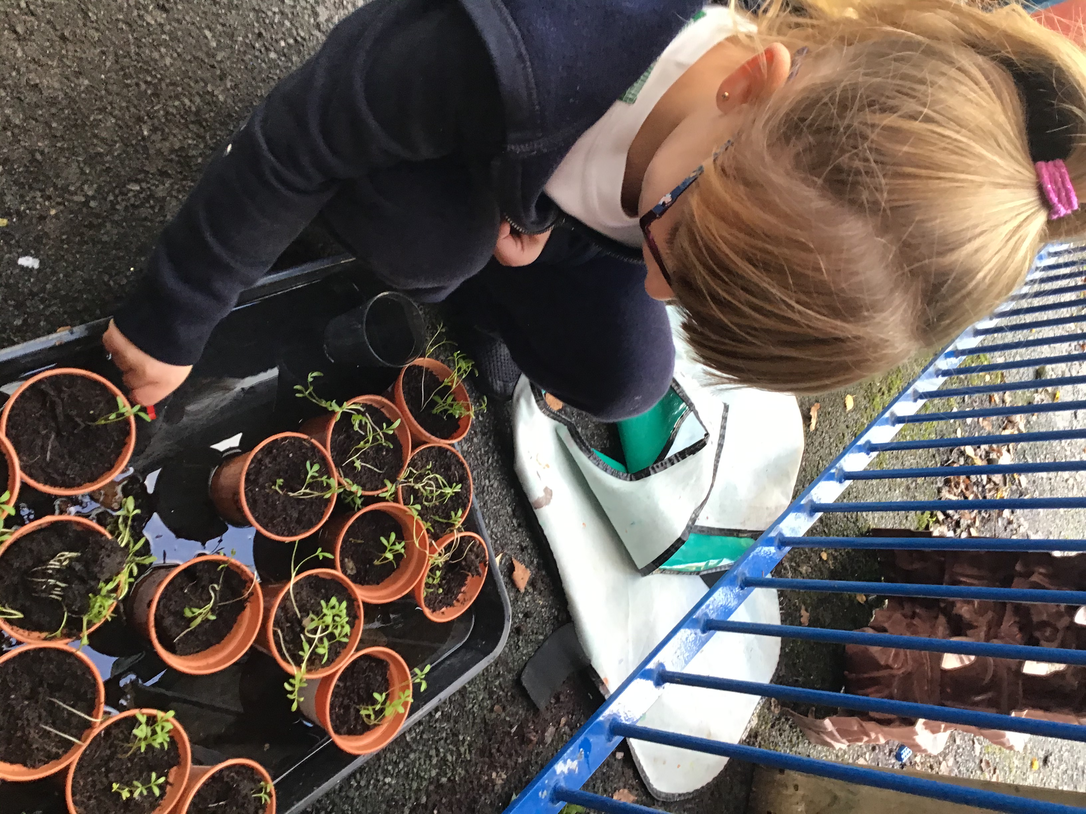We talked about different kinds of seeds and how we can plant seeds to grow our own plants. We decorated our plant pots and planted some cress seeds in our outdoor area.

