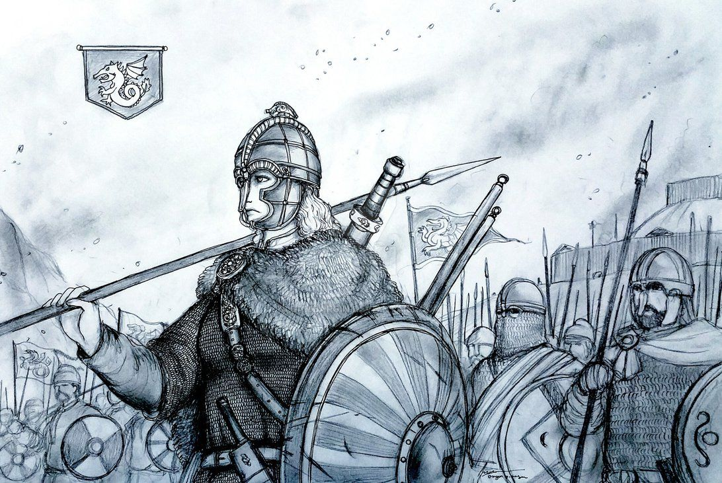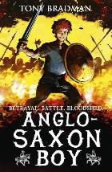

**As a scientist we will be…**

* Finding out how humans change during old age.
* Finding out about the gestation periods of different animals.

Year 5

Autumn term

**As a reader we will be…**

* Identifying grammar features that Tony Bradman uses to set the scene in Anglo-Saxon Britain.

**As a mathematician we will be…**

* Interpreting data from a bar chart, pictogram and line graphs.
* Recapping our 7, 8 and 9 times tables.
* Multiplying 4 digit numbers by 1 and 2 digits.
* Dividing 4 digit numbers by 1 and 2 digits.

**As a writer we will be…**

* Writing a recount from the point of view of an Anglo-Saxon in battle.
* Using adverbs of time, place and manner to add detail to our recounts.

**As a historian we will explore…**

* Anglo-Saxon houses and villages.
* The types of transport that the Anglo-Saxons used.
* Which products the Anglo-Saxon’s traded at the market.
* The social and religious diversity during this time.

**As a designer we will be…**

* Using computer aided software to design a pattern.
* Using plastic needles and weaving cards to create Anglo-Saxon Patterns.