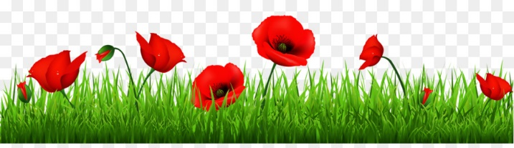

Year 2

Curriculum Map Autumn 2

**Creative Curriculum**

This half-term term our topic is ‘Let’s Remember’. We will be learning about the first and second World Wars and discussing the importance of Remembrance Day and why people wear poppies. We will examine what life was like in the trenches and look at the role of animals in the wars including Sergeant Stubby. We will study the life of a significant individual - Walter Tull who was a footballer and soldier in WWI and became recognised as the first black officer to lead British soldiers into battle.

**Science**

Our topic this half-term is ‘Uses of everyday materials’.

We will be learning about different materials including wood, metal, glass, paper and plastic and many more and explore their different uses. We will investigate how the shapes of solid objects can be changed by squashing, bending, twisting and stretching.

**Religious Education**

Our RE focus question is ‘Why and how are Christmas and Chanukah celebrated?’ We will explore different festivals that are celebrated all over the world and in different religions. We will learn about the true meaning of Christmas and retell the bible story that underpins this.

**Maths**

We will continue to follow the White Rose Maths scheme and learn through a concrete, pictorial and abstract approach. This half-term we will be focussing on addition and subtraction and multiplication and division. We will learn how to add 2-digit numbers and use the inverse relationship to solve number problems. We will also be practising the 2, 5 and 10 times tables.

**English**

We will continue to use Read Write Inc. to teach phonics. Your child will be learning and recapping all the phonemes and graphemes to ensure that they are confident to segment and blend sounds in order to read both real and alien words. Your child will also engage in daily reading practise through the scheme.

Our ‘book as hook’ for this half-term is ‘Stick Man’ by Julia Donaldson. We will be writing narratives, diary entries and instructions based on the text. We will be using our phonics knowledge to spell words and ensuring that we use the appropriate punctuation and grammar in our writing.

P.E. will take place on a Tuesday this half-term. Please send your children into school in their P.E. kit on Tuesday. Thank you.