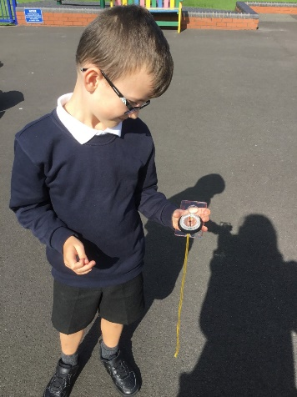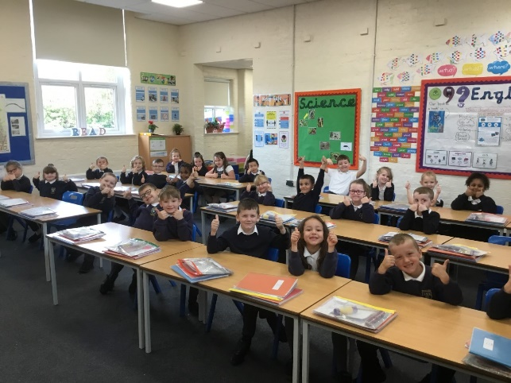

We have been completing fieldwork on our outside area using a compass to identify directions.

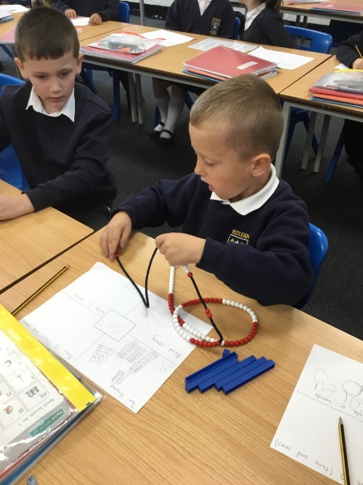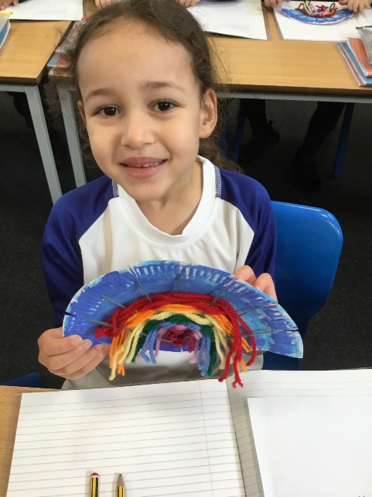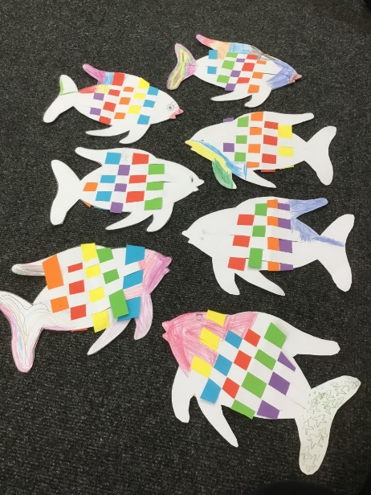

We created rainbow fish paper weavings inspired by our book as a hook ‘The Rainbow Fish’.

We celebrated World Mental Health day by sharing a smile with our fellow classes!

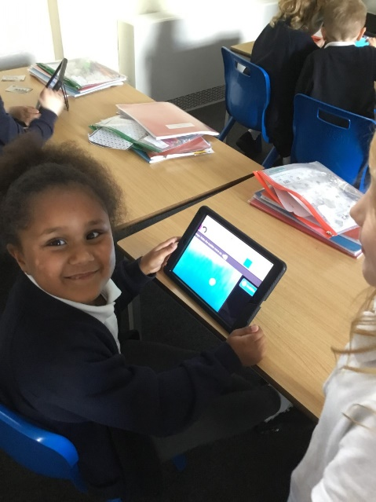

We have been completing coding challenges on Purple Mash as part of our computing lessons.

We learnt how to use a needle and thread to create beautiful rainbow weavings in DT!

We have been using concrete objects to help us solve mathematical problems.