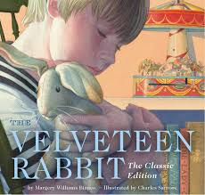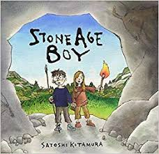

**As a reader, we will…**

* Explore our story the Velveteen Rabbit by learning how to infer an author’s meaning.

**Year 3**

**Autumn**

**Term 1**

**As a writer, we will…**

* Write letters to the future describing the Stone Age.
* Create setting descriptions.
* Write diary entries.
* Learn to use determiners.

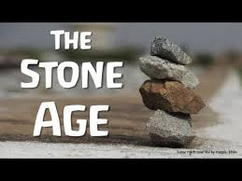

**As an artist we will be…**

**Creating Collage Art:**

**Use a variety of techniques,** e.g. printing, dying, quilting, weaving, embroidery, and paper and plastic trappings.

Artist study: Robert Rauschenberg

**As a mathematician we will be…**

* Learning about the place value of numbers up to 1000.
* Learning our 4 and 8 times table.
* Learning how to add/subtract 1’s, 10’s and 100’s.

**As a designer, we will…**

* Explore famous designers such as Donna Wilson/Vivienne Westwood.
* Create our own printed t-shirt

**As a scientist, we will be…**

* Learning what nutrition our body needs to survive.
* Exploring how skeletons work.
* Finding out what important organs skeletons protect.
* Naming important bones in our body.

**In Religious Education, we will be…**

* Learning about different religious books and why they are important to religion.

**As a musician we will be…**

* Listening to a range of instruments and learning about the art of music from a professional teacher.

Let Your Spirit Fly. The material presents an integrated approach to music where games, the dimensions of music (pulse, rhythm, pitch etc), singing and playing instruments are all linked.Learning about different instruments with a

**As a Historian we will…**

Be exploring the ways of life during the Stone Age including their types of homes, survival skills, and similarities to humans today.

Create our own cave art and woolly mammoths.