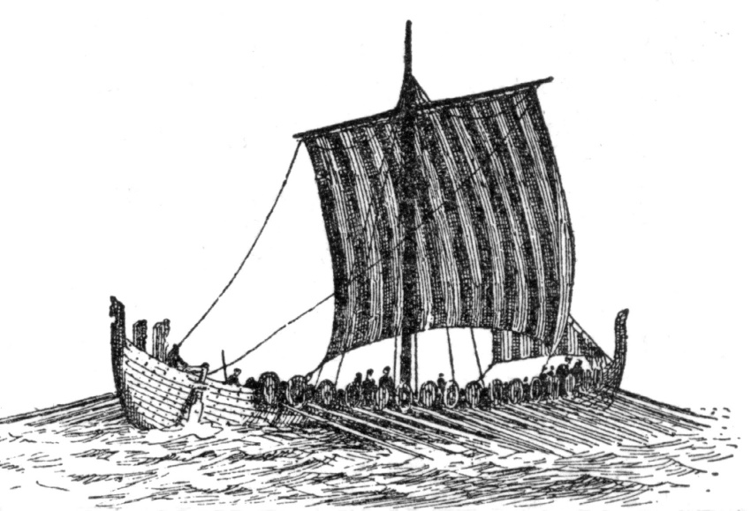

**As a mathematician we will be…**

* Reading and writing numbers to 1, 000,000.
* Comparing numbers to 1, 000,000.

**As a writer we will be…**

* **Writing a setting description of the rainforest.**
* **Using persuasive language to write a letter to companies who use palm oil.**

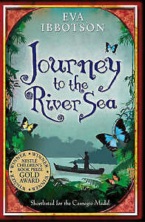

**As a reader we will be…**

* Identifying grammar features Eva Ibbotson uses to write a setting description.

Year 5

Autumn term

**As a scientist we will be…**

* Observing and comparing the lifecycles of animals in their habitats.
* Finding out about reproduction of animals and plants.

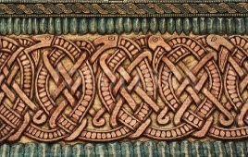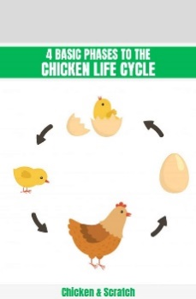

**As an artist we will be…**

* Using card and mark making tools to control, line, shape, texture and tone.
* Creating Anglo-Saxon Patterns.

**As a historian we will explore…**

* Viking raids and invasion.
* Resistance by Alfred the Great and Athelstan, first king of England.
* Viking invasions and Danegeld.
* Anglo-Saxon laws and justice.